Robustness to Missing Biosignal Modalities in Multimodal Stress Detection

Sankar S Pillai  School of Computer Science and Engineering (SCOPE)  Vellore Institute of Technology, Chennai Campus,  Chennai, Tamil Nadu  sankarspillai77@gmail.com | Martin Wills  School of Computer Science and Engineering (SCOPE)  Vellore Institute of Technology, Chennai Campus,  Chennai, Tamil Nadu  manu.wills11@gmail.com | N Prem Sankar  Centre for Healthcare Advancement Innovation and Research (CHAIR)  Vellore Institute of Technology, Chennai Campus,  Chennai, Tamil Nadu  premsankar.n@vit.ac.in

Abstract—Most of the wearable stress detection systems are trained and evaluated under the assumption that all the sensors are available at inference time. But in real world scenarios, in many cases sensors routinely fail due to external factors such as electrode detachment, motion artifacts, battery exhaustion, or signal saturation which all cause a modality dropout. In our paper we present a robustness benchmark that compares different handcrafted-feature models (SVM, Random Forest, XGBoost) against two Deep Learning models (CNN and CNN-LSTM) on WESAD dataset. WESAD (Wearable Stress and Affect Detection) is a widely used public multimodal dataset introduced for research in wearable stress detection. It features physiological signals of 15 subjects while wearing physiological sensors. It contains data from both chest worn sensors and wrist worn sensors. For this paper we use the four chest modalities (electrocardiogram [ECG], electrodermal activity [EDA], respiration, and temperature) on which we train Random Forest, Support Vector Machines (SVM) and then XGBoost on an 11-dimensional handcrafted feature vector the followed by training a multimodal Convolutional Neural Network (CNN) and a Convolutional Neural Network–Long Short-Term Memory (CNN-LSTM) on raw downsampled signal windows and then evaluated on Leave-One-Subject-Out (LOSO). We then simulate sensor failure at inference time by zeroing the internal embedding (deep models) or the corresponding feature slice (handcrafted models) for one or more modalities. Robustness Score (RS), defined as the ratio of Macro-F1 under a missing-modality condition to Macro-F1 under full modality availability, and evaluate the best-performing model (CNN-LSTM) across 4 single-dropout and 10 multi-dropout scenarios without any retraining. The CNN-LSTM model achieves the best full modality performance (Macro-F1 = 0.879 ± 0.105), narrowly outperforming an SVM baseline (0.875 ± 0.077) and a plain CNN (0.849 ± 0.149). During the modality dropout experiment it is found out that ECG is the most critical modality while respiration is least critical single modality.
Keywords- WESAD, convolutional neural network, LSTM, wearable sensors, stress detection, missing modality robustness

Introduction
Continuous, unobtrusive physiological monitoring is one of the primary goals of modern wearable healthcare. The confluence of recent advances in miniature biosensors, embedded signal processing, and ubiquitous wireless communication has enabled unprecedented versatility and accessibility of clinical-grade ECG, EDA, respiration, and temperature measurements, from the hospital ward to the home environment and beyond. Within this space, the ability to automatically detect stress is one of the problems of paramount interest. Stress is a known physiologically taxing state, often preceding a broad range of negative health outcomes ranging from cardiovascular events and immunosuppression to psychological disorders [1], while remaining amenable to early and continual intervention. Not only does an individual's ability to recognize and mitigate excessive stress levels benefit personal well-being, but stress-aware solutions are also actively sought in occupational settings to reduce worker burnout and improve safety. Furthermore, personalized medicine increasingly aims to incorporate affective state as part of routine physiological assessment [16]. With the promise of long-term ambulatory monitoring and ubiquitous deployment, affective computing has shifted from controlled laboratory environments toward real-world applications, making wearable stress monitoring an increasingly important research area.
The literature on continuous wearable stress detection has explored two broad classes of methods. One class relies on handcrafted physiological features extracted from biosignal time series. These typically include heart rate variability (HRV) features derived from ECG, tonic and phasic components of EDA, respiration characteristics, and temperature trends, which are subsequently processed using conventional machine learning algorithms such as Support Vector Machines (SVM) [8], Random Forests (RF) [7], and gradient-boosted trees [6]. The second class consists of deep learning architectures, with Convolutional Neural Networks (CNNs) and CNN–Long Short-Term Memory (CNN-LSTM) networks being widely adopted for learning discriminative representations directly from raw or transformed physiological signals [9]. Both approaches have been extensively evaluated using the WESAD dataset, a multimodal benchmark containing synchronized chest- and wrist-worn physiological recordings under baseline, stress, and amusement conditions. Most studies report strong performance under subject-independent evaluation protocols and demonstrate the benefits of multimodal sensor fusion [20].
However, the encouraging results reported on WESAD and similar datasets are generally obtained under an implicit assumption that all physiological sensors remain fully functional throughout both training and inference. In real-world deployments, particularly for chest-mounted sensors, motion artifacts, electrode detachment, hardware failures, communication interruptions, and battery depletion can result in intermittent or permanent loss of one or more sensing modalities [23]. A practical stress detection system must therefore maintain acceptable performance even when only a subset of the physiological signals is available. Despite its practical importance, the literature provides limited evidence regarding how existing stress detection models behave under such conditions. Most studies, whether based on handcrafted features or deep learning, report performance only under ideal full-modality availability or use this setting solely as a comparison baseline [20]. Consequently, little is known about the robustness of these models when one or more physiological modalities become unavailable during inference.
When missing modalities are considered in the broader multimodal learning literature, the focus is typically placed on developing new architectures or reconstruction techniques capable of compensating for incomplete input data [17]. Comparatively little attention has been given to systematically evaluating the intrinsic robustness of existing wearable stress detection methods without introducing retraining, modality reconstruction, or imputation techniques. As a result, it remains unclear whether handcrafted machine learning models and deep learning architectures exhibit fundamentally different degradation characteristics when operating with reduced sets of physiological modalities.
To address this gap, the present work performs a comprehensive comparative study of the robustness of established stress detection models under controlled modality failure scenarios. Specifically, this work evaluates three classical machine learning models—Support Vector Machine (SVM), Random Forest (RF), and XGBoost—and two deep learning architectures—a multimodal CNN and a multimodal CNN-LSTM—using the WESAD dataset. All models are trained under complete-modality conditions; the best-performing model is subsequently evaluated under simulated sensor failures without retraining. Four single-modality dropout scenarios and ten multi-modality dropout scenarios are investigated using the Leave-One-Subject-Out (LOSO) evaluation protocol. The resulting performance degradation is analyzed statistically, and the relative contribution of each physiological modality toward overall stress detection performance is quantified.
To the best of our knowledge, this work is the first to jointly benchmark classical handcrafted-feature approaches and deep learning architectures under a standardized full-modality evaluation protocol on WESAD, and to further analyze the missing-modality robustness of the best-performing model in this comparison. The major contributions of this work are summarized as follows:
- A comprehensive comparison of classical handcrafted-feature models (SVM, RF, and XGBoost) and deep multimodal architectures (CNN and CNN-LSTM) for wearable stress detection on the WESAD dataset under a standardized Leave-One-Subject-Out evaluation protocol.
- A systematic robustness evaluation of the best-performing model across four single-modality and ten multi-modality sensor failure scenarios without retraining, closely simulating realistic sensor failures encountered in wearable healthcare systems.
- The introduction of a simple Robustness Score (RS) for quantifying relative performance degradation under missing-modality conditions, together with statistical significance analysis of performance changes across different dropout scenarios.
- An analysis of the relative importance of ECG, EDA, respiration, and temperature modalities for continuous wearable stress detection, providing practical insights into the design of robust multimodal healthcare systems.

Related Work

Wearable Stress and Affect Detection

Physiological stress detection from wearable sensors has a long history, dating back to work on detecting driver stress from ECG and skin conductance [2]. The WESAD dataset [1] was introduced to standardize evaluation on this task, providing synchronized chest- and wrist-worn recordings of ECG, EDA, respiration, temperature, electromyography, and acceleration from 15 subjects across baseline, stress (Trier Social Stress Test), and amusement conditions. Since its release, WESAD has become a common benchmark for both handcrafted-feature pipelines using heart-rate-variability and skin-conductance descriptors with classical classifiers, and for deep learning pipelines that operate directly on raw or lightly filtered signal windows.

Missing Modality Robustness

Robustness to missing input modalities has been studied extensively in multimodal machine learning more broadly, including strategies such as modality dropout during training [19], cross-modal reconstruction, and joint embedding spaces that degrade gracefully when a channel is absent [17],[18]. Within physiological sensing specifically, comparatively few studies systematically quantify how stress- or affect-detection accuracy degrades when individual chest or wrist sensors are unavailable at test time, and to the best of our knowledge no prior published benchmark on WESAD directly compares handcrafted and deep multimodal pipelines under a controlled, zero-masking dropout protocol identical across both pipeline families. This paper is designed to fill that gap.

Dataset and Preprocessing

Dataset
The dataset used for this study is the WESAD (Wearable Stress and Affect Detection) dataset [1], recorded at the University of Augsburg and publicly released through the UCI Machine Learning Repository. The released dataset contains recordings from 15 subjects (S2–S17, excluding S12). Subject S12 is omitted because of corrupted or incomplete recordings, while subject S1 is not included in the publicly released dataset. Among the available physiological signals, only the four chest-worn RespiBAN signals sampled at 700 Hz-electrocardiography (ECG), electrodermal activity (EDA), respiration (Resp), and skin temperature-are used in this study. The wrist-worn Empatica E4 signals, as well as the chest electromyogram (EMG) and accelerometer channels, are excluded because they were acquired using a different sensing device with an independent recording clock.

Rationale for Chest-Only Modality Selection
WESAD provides physiological signals from two devices operating at markedly different sampling rates: the chest-worn RespiBAN unit (ECG, EDA, respiration, and temperature, all at 700Hz) and the wrist-worn Empatica E4 (blood-volume pulse at 64Hz, EDA and temperature at 4Hz, and accelera tion). Combining both devices would require either upsam pling the low-rate wrist channels by orders of magnitude, aggressively downsampling the chest channels, or designing a multi-rate fusion architecture, any of which introduces a confound: if performance changes after removing a sensor, it would no longer be possible to determine whether the change is attributable to the missing physiological information itself or to the heterogeneous sampling/synchronization artifacts intro duced by mixing devices. Because the central objective of this study is to isolate the effect of missing modalities on stress classification performance, we restrict all experiments to the four chest-worn RespiBAN signals, which are synchronously recorded at an identical sampling rate under the same device. This design choice ensures that any observed performance degradation in the dropout experiments (Section VI) can be attributed with confidence to the absence of physiological information rather than to cross-device artifacts, at the cost of not evaluating robustness to the loss of wrist-worn sensors; this trade-off is revisited as a limitation in Section VIII

Label Construction
WESAD offers a label for each time step. We select only
segments labeled as baseline (label 1), stress / Trier Social Stress Test (label 2), and amusement (label 3), removing temporary and unnamed intervals (labels 0 and 4–7). Next, we map the labels to a binary stress task: stress (label 2) = 1, and baseline/amusement= 0.

Signal Preprocessing
Each mode is separately filtered using a zero phase(forward-backward) fourth order Butterworth filter, except for the temperature data, which is filtered using a Savitzky-Golay filter (window size 701 and polynomial order 2):
• ECG: bandpass from 0.5 to 40.0Hz (baseline wander removal, QRS complex preservation);
• EDA: bandpass from 0.05 to 5.0Hz (preservation of the phasic and tonic components);
• Respiration: bandpass from 0.05 to 1.0Hz (3-60 breaths/min range).
Each filtered signal is then z-score normalized on a per subject basis over the full continuous recording:

x̂ = (x − µ_{subject}) / (σ_{subject} + ϵ), ϵ = 10⁻⁸ (1)

No cross-subject statistics are used, avoiding subject-identity leakage.

Windowing
Continuous data for each individual is broken down into 30 seconds-long windows (each containing 21,000 samples sampled at 700 Hz) with stride of 15 seconds. Every such window receives the label corresponding to the majority of timesteps within the window. Windows overlapping the end of the subject’s data are omitted. For every subject we have an array X ∈ RN×4×21,000 and labels y ∈ {0,1}N.
In terms of the deep learning pipeline, each window is further downsampled from 700Hz to ∼100Hz by polyphase resampling , bringing the sequence length down from 21,000 to 3,000 per modality. The downsampling is performed to make CPU training feasible while maintaining the primary physiological frequencies.
In this way, the data tensor layout X ∈ R^{N×4×21,000} is such that all modalities appear on separate channels: getting one window (X[0]) results in a (4,21,000) tensor containing 84,000 synchronized measurements (4 modalities × 21,000 samples) during 30 seconds, while accessing one modality within this window (e.g. X[0,0,:] for the ECG) results in a (21,000,) tensor with data for this channel only. This is no coincidence: this kind of channel-wise separation is precisely why selective zeroing of individual modalities in Section IV-D becomes possible without affecting other modalities, and thus the key to the experiment that follow.

Dataset Statistics
Overall, there are 2,187 windows for all the 15 subjects where 644 (29.4%) are marked as stress and 1,543 (70.6%) as non-stress, thereby resulting in a moderate imbalance in the classes. The number of windows for each subject varies from 140 (S2) to 150 (S10, S17) with a proportion of stress windows varying between 28.7% and 31.3%.

Handicrafted Feature Extraction
In the classical machine learning pipeline, each 30-second window is transformed into an 11-dimensional feature vector using NeuroKit2 and SciPy [12]:
• ECG (4 features): RMSSD, SDNN, pNN50 (measures of heart-rate variability generated using neurokit2.hrv_time) and average heart rate (count of R-peaks / window duration) [13];
• EDA (3 features): mean tonic skin conductance level,
number of peaks in the skin conductance response (SCR) and average SCR amplitude [14];
• Respiration (2 features): mean breathing rate and
breathing rate variability;
• Temperature (2 features): mean temperature and
linear temperature slope.
If extraction of a feature using NeuroKit2 fails (for instance, less than 3 detected R-peaks), then the respective sub-vector becomes zero instead of being discarded, thus making sure that each window has a fixed-size feature representation. The four above-listed groups of features are also fixed-length
sub-vectors of the 11-dimensional vector, which will be used for simulating modality dropout in the classical pipeline.

Methodology
Model development was done in a staged manner driven by evidence and not through the use of one particular architecture from the start. First, we developed a baseline with handcrafted features (Section IV-A) with traditional classifiers because it is known that domain-specific physiological features are very good for LOSO stress detection and can serve as a benchmark for any learning method. Second, we developed an end-to-end CNN (Section IV-B) that worked directly on raw multimodal segments. Since the CNN did not surpass the best handcrafted baseline (Section VI-A), we came up with a CNN-LSTM hybrid model (Section IV-C) aimed at modeling temporal dynamics that are compressed into one feature vector by a pure convolutional encoder. Only after identifying the strongest learning method did we proceed with testing its robustness in the missing-modality setting .

Handcrafted Baseline Classifiers
Three classical classifiers are trained on the 11-dimensional feature vectors: Random Forest (300 trees) [7], Support Vector Machine (RBF kernel, probability estimates enabled) [8], and XG Boost [6], all with default regularization and a fixed random seed of 42. A StandardScaler is fit exclusively on the training partition [11]of each LOSO fold and applied, without refitting, to the held-out test subject, preventing test-set leakage.

CNN Architecture
The CNN architecture used as the base (MultiModalCNN) uses an independent 1-D convolutional encoder for each of the four modalities. Each ModalityEncoder is comprised of three Conv1d-BatchNormalization-ReLU blocks (progression in number of channels 1-32-64-128), and the strided downsampling is done at every layer with a factor of 2, then an adaptive average pooling to a fixed size of 64 and a fully connected projection to a 128-dimensional embedding space. Four separate embeddings of the four modalities (512 dimensions overall) are concatenated and fed into a classifier that contains two hidden layers (dimensions of the layers 512-128-64, activation function ReLU, dropout 0.3) and a final linear layer of 2 classes.

TABLE I: CNN Embedding-Dimension Benchmark (10-Epoch Validation Run)

Embed. Dim. | Val. Macro-F1 | Time (10 ep.)
256 | 0.9923 | 250.0 s
128 (adopted) | 1.000 | 150.6 s

Embedding-dimension selection: The per-modality embedding dimension was originally planned as 256, matching the classifier-head width used in early design notebooks. A short benchmarking study compared this 256-dimensional configuration against a reduced 128-dimensional configuration on a held-out validation split over 10 training epochs (Table I). The reduced 128-dimensional model matched or exceeded the validation Macro-F1 of the larger model while reducing wall clock training time by approximately 40%, and was therefore adopted as the default configuration for all full LOSO training runs reported in this paper.

CNN-LSTM Architecture

Motivation for temporal modeling: The Modality Encoder used by plain CNN compresses an entire 30-second window into a single static embedding via adaptive average pooling, discarding the ordering of the signal within the window. Physiological stress responses, however, are inherently temporal: gradual rises in electrodermal activity, fluctuations in heart-rate variability, evolving respiration trends, and delayed autonomic responses to a stressor can all unfold over multiple seconds within a single window. A purely convolutional encoder with a small receptive field is not well suited to represent such longer-range sequential dependencies. This motivated replacing the final pooling-to-embedding step with an explicit sequence-modeling stage, described next.
The CNN-LSTM model (MultiModalCNNLSTM) replaces the deep convolutional stack with a shallower two-layer Conv1d encoder (1 → 32 → 32 channels) per modality, followed by adaptive average pooling to a sequence length of 50 and a single-layer LSTM (hidden size 32) that summarizes the pooled sequence into a final hidden state [9]. A linear projection maps this 32-dimensional hidden state to a 64-dimensional per-modality embedding. The four 64-dimensional embeddings are concatenated (256 dimensions total) and passed through a classifier head (256 → 256 → 64, ReLU, dropout 0.3) to a final 2-class linear layer. This optimized configuration contains approximately 147,000 parameters, substantially fewer than a non-optimized variant explored during development (approximately 521,000 parameters, conv_channels=64, lstm_hidden=64, embed_dim=256), which was not used for any reported result.

Missing-Modality Simulation
Modality dropout is done solely at inference time without any retraining or finetuning. In the case of deep models, a binary mask indicating missing modality is applied on the modality-specific embeddings output by the per-modality encoder: if the ith modality is marked as missing, then the embedding vector is replaced with a zero vector of the same dimensionality before concatenation. The encoder itself is run, however, its output is not used; therefore, there is no runtime cost involved while the resulting representation reflects that this modality has no data available whatsoever. In the case of the handcrafted SVM model baseline, the equivalent procedure involves setting the feature vector’s slice that corresponds to the missing modality to all zeroes after the StandardScaler transformation (Section IV A) – this reflects “no information” in the normalized feature space. The four dropout scenarios considered are as follows: No ECG, No EDA, No Respiration, and No Temperature. We also consider ten multi-modality dropout cases: six where two modalities are missing and four where one modality survives. Results for this simulation are reported for the CNN-LSTM model (Section VI); the corresponding handcrafted and CNN robustness results are left to future work, as noted in Section VIII

Robustness Score\
For each subject s and dropout scenario k, we define the Robustness Score as

$${RS}_{s,k}=\frac{{F1}_{s,k}^{missing}}{{F1}_{s}^{full}} (2)$$

where F1full, is the Macro-F1 achieved by the model on subject s’s held-out test fold with all four modalities present, and F1missing s,k is the Macro-F1 achieved on the same fold under dropout scenario k. Per-scenario RS is reported as the mean and standard deviation of RSs,k across all 15 subjects. An RS of 1.0 indicates no degradation; values below 1.0 indicate degradation; values above 1.0 (observed for a small number of individual subjects) indicate that removing a modality incidentally improved performance for that subject, discussed further in Section VII.

Experimental setup

Cross-Validation Protocol
All models are evaluated using Leave-One-Subject-Out (LOSO) cross-validation across the 15 available subjects, ensuring subject-independent generalization: no windows from the test subject appear in training. For the deep models, subject S17 is used as a fixed validation subject for early stopping in every fold except when S17 itself is the test subject, in which case S16 is used instead. The handcrafted SVM baseline does not require a validation subject, since classical classifiers are not early-stopped, and therefore trains on all 14 non-test subjects (versus 13 for the deep models), a minor training-data asymmetry noted as a limitation in Section VIII.

TABLE II: Full-Modality Performance (Mean ± Std over 15 LOSO folds)
Model | Accuracy | Macro-F1 | AUROC
Random Forest | 0.881 ± 0.076 | 0.855±0.095 | 0.957 ± 0.059
XGBoost | 0.882 ± 0.073 | 0.847±0.105 | 0.972 ± 0.029
Handcrafted + SVM | 0.895±0.063 | 0.875±0.077 | 0.972
CNN | 0.893 ± .086 | 0.849± 0.149 | 0.9705
CNN-LSTM | 0.897 ± .094 | 0.879± 0.105 | 0.9481

Deep Model Training
For both the CNN and the CNN-LSTM models, the Adam optimizer [10] (learning rate 10−3, weight decay 10−4), cosine annealing learning rate schedule, and class-weighted cross entropy loss, in order to address the class imbalance (of approximately 70/30), are used. Class weights are determined based on the label distributions in the training set per fold by
taking the inverse class frequency normalized to sum to the
number of classes. The CNN is trained for up to 50 epochs using early stopping (patience 10 based on validation Macro-F1), while the CNN-LSTM is trained for up to 30 epochs using early stopping (patience 8). Batch sizes of 32 and 64 are used for training and evaluation, respectively. The two models are trained using CPU (Intel i5-13500H,12 cores). A fixed random seed of 42 is set at the beginning of each LOSO fold.

Evaluation Metrics
We report Accuracy, Macro-F1, and Area Under the ROC Curve (AUROC) for the full-modality condition, and Macro F1 together with the Robustness Score for all dropout scenarios. Macro-F1 is treated as the primary metric throughout, as it weights both classes equally regardless of their frequency and is therefore less sensitive than raw accuracy to the ∼70/30 class imbalance present in WESAD.

Statistical Testing
For each single-modality dropout scenario, we compute a paired t-test (scipy.stats.ttest_rel) comparing per subject Macro-F1 under full modality versus under the dropout scenario, across all 15 LOSO folds. We additionally report 95% confidence intervals on the percentage performance drop, computed as 1.96 × SEM of the per-subject drop values.

Results

Full-Modality Performance
Table II compares all five models when all modalities are available; Figure 1 illustrates the three models discussed in detail throughout this paper. The CNN-LSTM network outperforms other methods on the basis of Macro-F1 metric (0.879 ± 0.105), with a slight advantage over the SVM network (0.875 ± 0.077) and a significant margin over the CNN method (0.849 ± 0.149), which demonstrates the largest subject-to-subject variance among the three models. AUROC measures of the three methods are as follows: SVM (0.972), CNN (0.9705), and CNN-LSTM (0.9481). Therefore, even though the CNN-LSTM model demonstrates the best hard-decision Macro-F1 value, its probability calibration is somewhat inferior to the classical one.
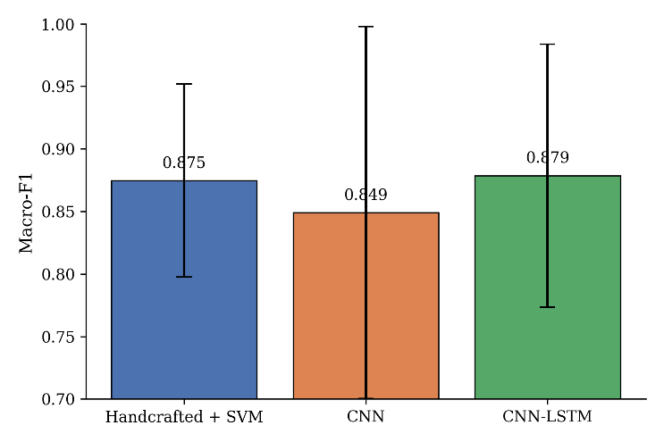
Fig. 1: Full-modality Macro-F1 comparison across the handcrafted SVM, CNN, and CNN-LSTM pipelines. Error bars denote standard deviation across the 15 LOSO folds.

TABLE III: Largest CNN Full-Modality Failures Relative to Hand crafted SVM
Subject | SVM F1 | CNN F1 | Δ (CNN − SVM)
S9 | 0.893 | 0.437 | −0.456
S4 | – | 0.696 | −0.295
S15 | – | 0.739 | −0.139

The model ranking on the basis of mean Macro-F1 score is as follows: CNN-LSTM (0.879) > SVM (0.875) > XGBoost (≈0.857) > Random Forest (≈0.855) > CNN (0.849). With complete modality, the mean accuracy obtained for the CNN model is 0.893 ± 0.086, which is greater than the Macro-F1 and accuracy scores obtained by SVM. This highlights the reason why Macro-F1 score was selected as the main evaluation measure, as the accuracy is biased due to non-stress cases.

Subject Level Analysis of Learned Representations
Values of aggregate Macro-F1 scores hide substantial variability from subject to subject, which is important in relation to robustness evaluations. Table III gives the list of the three subjects on which the basic CNN performs most poorly in comparison to the hand-crafted SVM model in full modality. The most drastic difference occurs on S9: the SVM achieves Macro-F1 = 0.893 on S9, while the CNN achieves 0.437, representing more than 46 points of degradation. On the other hand, the CNN outperforms the SVM significantly on some other subjects (for example, 0.212 F1 improvement on S5 and 0.195 F1 improvement on S13). Thus, the CNN can learn very discriminative representations on some subjects but not others.
As seen in Table IV, adding the LSTM layer for temporal modeling significantly improves the performance in subject-level failures. For example, in the case of S4, the Macro-F1 value changes from 0.696 using CNN to 0.907 using CNN-LSTM. Similarly, in the case of S9, which is the most difficult subject in both deep learning models, the Macro-F1 score is improved from 0.437 to 0.631. Even though S9 stays the most difficult subject in both CNN and CNN-LSTM models, indicating the existence of subject-level variabilities, the positive change in the Macro-F1 value for S9 and other failed subjects can be interpreted as follows.

TABLE IV: CNN vs. CNN-LSTM Macro-F1 on Previously Weak Subjects

Subject | CNN F1 | CNN-LSTM F1
S4 | 0.696 | 0.907
S8 | 0.895 | 0.992
S9 | 0.437 | 0.631

TABLE V: Single-Modality Dropout: CNN-LSTM Macro-F1 and Robustness Score

Scenario | Macro-F1(Mean± Std) | RS (Mean ± Std)
Full | 0.879 ± 0.105 | 1.000 ± 0.000
No ECG | 0.780 ± 0.133 | 0.895 ± 0.161
No EDA | 0.850 ± 0.135 | 0.967 ± 0.092
No Respiration | 0.870 ± 0.118 | 0.989 ± 0.053
No Temperature | 0.841 ± 0.155 | 0.952 ± 0.102

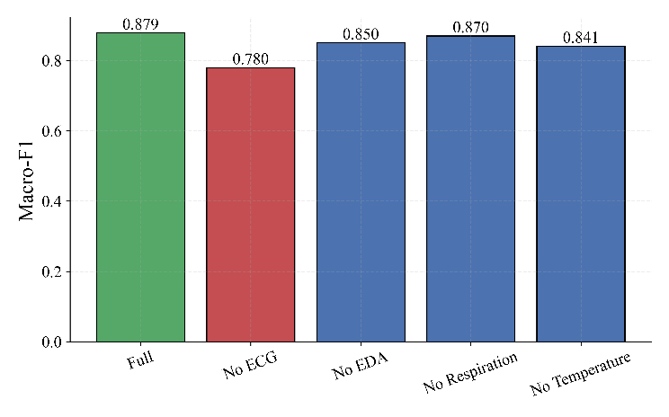
Fig. 2: CNN-LSTM Macro-F1 under full modality and each single modality dropout scenario.

Single-Modality Dropout
Table V shows the values of Macro-F1 and RS for the CNN-LSTM framework when applying dropout on each of the modalities individually, taking the average of the values calculated for all 15 subjects. The exclusion of the ECG channel leads to the largest reduction in performance, which falls from 0.879 to 0.780 (RS = 0.895 ± 0.161). The absence of the respiration channel produces minimal impact on performance (Macro-F1 = 0.870, RS = 0.989 ± 0.053), whereas the absence of temperature (Macro-F1 = 0.841, RS = 0.952) and EDA (Macro-F1 = 0.850, RS = 0.967) has a more significant effect.

Modality Importance and Statistical Significance
In Figure 4, the modalities are ordered by mean percentage decrease in the Macro-F1 score after their elimination: ECG (10.51%) > Temperature (4.76%) > EDA (3.34%) > Respiration (1.07%). Table VI shows the results of the paired t-test and 95% confidence intervals for the percentage decrease. ECG is the only modality to be statistically significant (α=0.05; t = 2.82, p = 0.0136), while the other modalities (EDA, respiration, and temperature) do not have significant impact on the system’s ability to classify subjects’ states. The large values of confidence intervals that contain the 0 value point to high inter-subject variability in influence of each modality on classification of individuals.

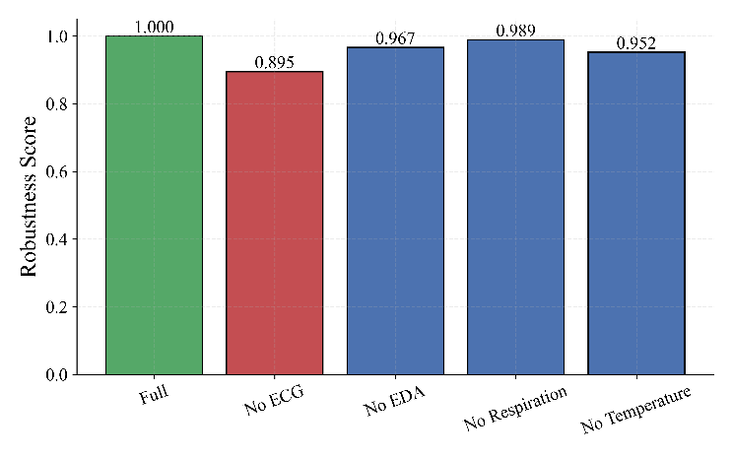
Fig. 3: CNN-LSTM Robustness Score under full modality and each single-modality dropout scenario.

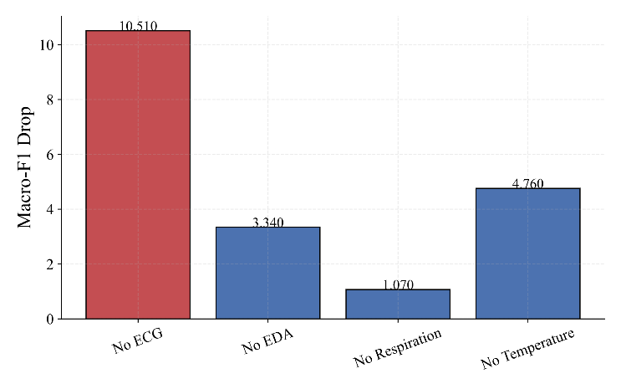
Fig. 4: Mean Macro-F1 drop (percentage points) when each modality is individually removed, ranked by importance.

TABLE VI: Paired t-test on Full vs. Single-Dropout Macro-F1 (n = 15 folds) and 95% CI on Percentage Drop

Scenario | Mean Drop (%) | 95% CI | t (p)
No ECG | 10.51 | ±8.16 | 2.820 (0.0136)
No Temperature | 4.76 | ±5.15 | 1.731 (0.1054)
No EDA | 3.34 | ±4.64 | 1.404 (0.1822)
No Respiration | 1.07 | ±2.70 | 0.828 (0.4213)

Figure 5 illustrates the same effect by showing the absolute value of Macro-F1 score decrease for each of the dropout cases compared to full-modality case.

Multi-Modality Dropout
Table VII and Figures 6–7 expand the investigation to ten multi-modality dropout conditions: six conditions with dropouts of two modalities and four conditions with one surviving modality (single-sensor condition). The most tolerant two-modalities dropout is No Respiration + No Temperature (Macro-F1 = 0.828, RS = 0.940), which is consistent with the result that the two are the least important individually. The least tolerant two-modalities dropout is No ECG + No EDA (Macro-F1 = 0.729, RS = 0.840), which is consistent with the most important modality of ECG. Among four conditions with single-surviving sensor, No Sensors Except ECG leads to the best performance (Macro-F1 = 0.732, RS = 0.824), while No Sensors Except Respiration achieves the worst performance (Macro-F1 = 0.628, RS = 0.721), which is the worst condition among all multi-dropout situations. Such a result is due to the fact that respiration contributes the least discriminative information to binary stress classification, consistent with its low importance obtained in single-dropout experiments.
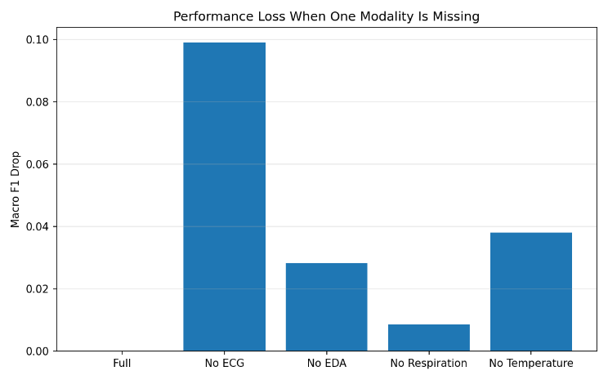
Fig. 5: Absolute Macro-F1 drop relative to full-modality performance for each single missing modality.

TABLE VII: Multi-Modality Dropout: CNN-LSTM Macro-F1 and Robustness Score
Scenario | Macro-F1 (Mean ± Std) | RS (Mean ± Std)
Full | 0.879 ± 0.105 | 1.000 ± 0.000
−Respiration, −Temperature | 0.828 ± 0.162 | 0.940 ± 0.130
−EDA, −Respiration | 0.818 ± 0.147 | 0.928 ± 0.193
−EDA, −Temperature | 0.772 ± 0.221 | 0.869 ± 0.198
−ECG, −Respiration | 0.760 ± 0.147 | 0.876 ± 0.193
−ECG, −Temperature | 0.730 ± 0.174 | 0.843 ± 0.231
−ECG, −EDA | 0.729 ± 0.166 | 0.840 ± 0.212
Only ECG | 0.732 ± 0.237 | 0.824 ± 0.222
Only Temperature | 0.725 ± 0.195 | 0.837 ± 0.249
Only EDA | 0.725 ± 0.208 | 0.833 ± 0.245
Only Respiration | 0.628 ± 0.154 | 0.721 ± 0.180

Discussion

ECG as the Dominant Modality
All results point to electrocardiogram (ECG) as being the most informative single modality when classifying chest-based stress levels. The greatest reduction of the macro F1 in single-modality scenario is found on the ECG drop (10.51%) which is the only single-drop that is statistically significant; also, the combination of the ECG with any other modality produces the two worst performing scenarios for the multi-drop scenario. This finding supports the established correlation between the activation of the autonomic nervous system and heart rate variability changes during stress and shows that the heart rate related data cannot easily be replaced by respiration, EDA, or temperature.
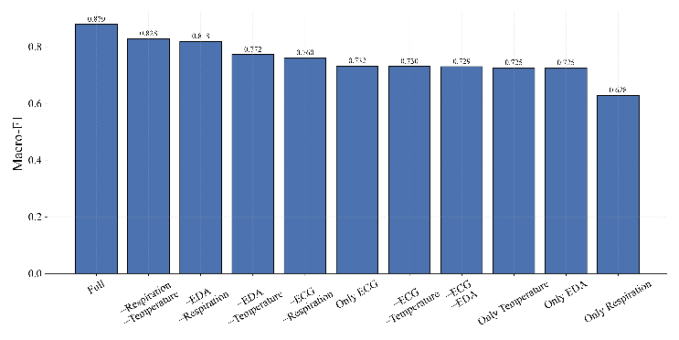
Fig. 6: CNN-LSTM Macro-F1 across all multi-modality dropout scenarios, ordered from least to most severe.

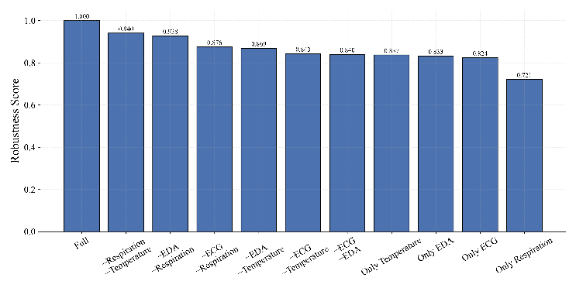
Fig. 7: CNN-LSTM Robustness Score across all multi-modality dropout scenarios, ordered from least to most severe.

Respiration as the Most Dispensable Modality
In contrast, however, respiration is consistently the least effective single modality; it provides the smallest reduction for one modality dropped (1.07% – non-significant) and causes the most moderate decrease when combined with temperature (two missing modalities). On the other hand, respiration alone (all others excluded) gives the most harmful multi-dropout situation (RS = 0.721), which means that respiration can be effectively used together with other modalities but performs badly as a single stress prediction variable.

Robustness Scores Exceeding 1.0
There are a number of cases where individual RS values for subject/scenario fall above 1.0, rather than being aligned with or falling at the baseline level of full modality. For example, for the held-out fold of subject S9, removal of ECG improves Macro-F1 score from 0.631 to 0.772 (RS = 1.223). As subject S9 was the most difficult subject under full modality (worst performing fold under the CNN-LSTM model), this indicates that, for this particular individual, the ECG data was somehow misleading and acted as a confounder, rather than representing stress. These types of cases have been kept intact with full accuracy and naturally arise due to averaging of RS across a diverse set of subjects; they don’t change the overall population-based observation that ECG is the most informative modality.

Handcrafted vs. Learned Representations
Under full modality conditions, the Macro F1 of the CNN-LSTM model enjoys only a small improvement on the SVM baseline (+0.004), and indeed, the SVM achieves an even higher AUROC. This suggests that, for chest WESAD data specifically, handcrafted features that capture HRV, skin conductance, respiration rate, and temperature slope contain a large amount of discriminative information that a deep network must extract from raw inputs. The main reason for using the deep model pipeline here is not its ability to improve upon full modality accuracy, but rather its ability to imitate missing modality performance by artificially destroying the learned embedding after encoding in a way that is similar to, but structurally different from, handcrafting zeros in a feature slice.
The findings presented in section VI-B with respect to the subject-level analysis further validate the overall narrative by another viewpoint: the hand-crafted SVM baseline exhibits relatively low variance between subjects. This is consistent with the intuition behind the use of domain-specific features as a form of inductive bias for better generalization to novel subjects. On the other hand, the bare-bones CNN is based on learned features, which are more prone to subject-wise overfitting due to the data-driven nature of the process and thus results in clear failures of the model per certain subjects (for example, S9) as well as clear successes of the model per certain subjects (for instance, S5, S13). The time modeling component of CNN–LSTM mitigates, but does not remove, this difference, which corresponds to the idea that the temporal dynamics of physiological signals contain discriminative information that convolutional pooling cannot capture.

Practical Implications
When developing wearable devices, this experiment shows that more work needs to be invested into ECG sensor implementation than in the case of other three chest sensors. This is caused by the fact that the loss of ECG sensor causes the largest decrease in accuracy of stress detection which is statistically significant. In addition, brief interruptions in the respiration channel can be tolerated without switching to backup plan, as long as ECG and another sensor work properly.

Limitations
Several caveats should be noted while considering these results. Firstly, each experiment is based on one dataset (WESAD, 15 subjects), and generalization of the findings beyond this particular population, device, or stress protocol has not been investigated. Secondly, as mentioned above, Section III-B, only RespiBAN modalities of chest-worn device were considered; wrist-worn Empatica E4 data included in WESAD have been deliberately removed in order to ensure internal validity of the robustness experiment by separating modality-missing effect from cross-device resampling synchronization issues. The latter control is necessary to compare the robustness performance of the models but implies that the findings cannot be generalized to heterogenic multi-device wearables with possible sensor failures. Thirdly, the model selection procedure was conducted using a fixed validation subject (S17, or S16 if S17 is used as the test subject); a fully nested leave-one-subject-out (LOSO) validation technique has not been used. In addition, the handcrafted SVM baseline model is trained using one additional subject per fold, unlike the deep learning architectures, because of the absence of the validation split. Fourthly, all random seeds per fold have been fixed to 42 and have not been averaged across multiple seeds; therefore, variances obtained from the experiments are the results of inter-subject variability only. Fifthly, modality missing simulation involved complete zero masking of modality embedding/feature slice; thus, it simulates complete sensor failure but does not take into account partial data loss, additional noise, and motion artifacts which are also typical failure scenarios; random dropout rate and Gaussian noise corruption scenarios were planned but not implemented in the current experiments. Finally, results are reported for the CNN-LSTM model in the case of missing modality experiment. A parallel missing modality experiment of the CNN architecture and handcrafted classifiers will be conducted in the future work.

Conclusion and Future Work
This paper presents a systematic benchmark of handcrafted and deep multimodal physiological models for wearable stress detection. We conducted tests under simulated sensor dropout on the WESAD dataset. A CNN-LSTM architecture achieved the best full-modality Macro-F1 score of 0.879, slightly ahead of a classical SVM baseline at 0.875. We defined a Robustness Score as the ratio of dropout to full-modality Macro F1. Our results showed that ECG is clearly the most critical of the four chest-worn modalities, with a 10.51% mean Macro-F1 drop when removed. This scenario was also the only statistically significant single dropout case, with a p-value of 0.0136. In contrast, respiration was the most dispensable modality, showing only a 1.07% mean drop. Multi-modality experiments further indicated that a model relying solely on respiration experienced the greatest degradation among all tested configurations, achieving a Robustness Score of 0.721. The combination of losing both respiration and temperature fared best among two-sensor failures, with a Robustness Score of 0.940. These findings offer a practical methodology for measuring and reporting sensor robustness in future wearable stress and affect-detection systems. Future work will extend the missing-modality evaluation to the CNN and handcrafted baselines under the same scenario. We will also incorporate partial degradation and noise-based corruption instead of complete zero-masking. Additionally, we plan to train with modality-dropout augmentation to optimize for robustness rather than only measure it afterward. Our goal is to validate these findings on more wearable stress datasets beyond WESAD. Another natural step is to include the wrist-worn Empatica E4 modalities that were excluded from this study. We will use a multi-rate fusion architecture designed to handle different sampling rates. This approach would allow us to extend the central robustness question addressed here to a true multi-device wearable setting. It could help determine if sensor redundancy across devices, not just across chest-worn channels, can further enhance robustness to individual sensor failures.

Data And Code Availability
The preprocessing pipeline, model implementations, and all result CSV files used to generate the tables and figures in this paper are available at https://github.com/iamsan06/multimodal-stress-detection-

References
- P. Schmidt, A. Reiss, R. Duerichen, C. Marberger, and K. Van Laerhoven, "Introducing WESAD, a multimodal dataset for wearable stress and affect detection," in Proc. 20th ACM Int. Conf. Multimodal Interaction (ICMI), Boulder, CO, USA, 2018, pp. 400-408.
- J. A. Healey and R. W. Picard, "Detecting stress during real-world driving tasks using physiological sensors," IEEE Trans. Intell. Transp. Syst., vol. 6, no. 2, pp. 156-166, Jun. 2005.
- G. Giannakakis, D. Grigoriadis, K. Giannakaki, O. Simantiraki, A. Roniotis, and M. Tsiknakis, "Review on psychological stress detection using biosignals," IEEE Trans. Affect. Comput., vol. 13, no. 1, pp. 440-460, 2022.
- J. He, K. Li, X. Liao, P. Zhang, and N. Jiang, "Real-time detection of acute cognitive stress using a convolutional neural network from electrocardiographic signal," IEEE Access, vol. 7, pp. 42710-42717, 2019.
- A. Reiss, I. Indlekofer, P. Schmidt, and K. Van Laerhoven, "Deep PPG: Large-scale heart rate estimation with convolutional neural networks," Sensors, vol. 19, no. 14, p. 3079, 2019.
- T. Chen and C. Guestrin, "XGBoost: A scalable tree boosting system," in Proc. 22nd ACM SIGKDD Int. Conf. Knowledge Discovery and Data Mining, San Francisco, CA, USA, 2016, pp. 785-794.
- L. Breiman, "Random forests," Mach. Learn., vol. 45, no. 1, pp. 5-32, 2001.
- C. Cortes and V. Vapnik, "Support-vector networks," Mach. Learn., vol. 20, no. 3, pp. 273-297, 1995.
- S. Hochreiter and J. Schmidhuber, "Long short-term memory," Neural Comput., vol. 9, no. 8, pp. 1735-1780, 1997.
- D. P. Kingma and J. Ba, "Adam: A method for stochastic optimization," in Proc. Int. Conf. Learn. Representations (ICLR), 2015.
- F. Pedregosa et al., "Scikit-learn: Machine learning in Python," J. Mach. Learn. Res., vol. 12, pp. 2825-2830, 2011.
- D. Makowski et al., "NeuroKit2: A Python toolbox for neurophysiological signal processing," Behav. Res. Methods, vol. 53, no. 4, pp. 1689-1696, 2021.
- Task Force of the European Society of Cardiology and the North American Society of Pacing and Electrophysiology, "Heart rate variability: Standards of measurement, physiological interpretation, and clinical use," Circulation, vol. 93, no. 5, pp. 1043-1065, 1996.
- W. Boucsein, D. C. Fowles, S. Grimnes, G. Ben-Shakhar, W. T. Roth, M. E. Dawson, and D. L. Filion, "Publication recommendations for electrodermal measurements," Psychophysiology, vol. 49, no. 8, pp. 1017-1034, 2012.
- A. Savitzky and M. J. E. Golay, "Smoothing and differentiation of data by simplified least squares procedures," Anal. Chem., vol. 36, no. 8, pp. 1627-1639, 1964.
- R. W. Picard, Affective Computing. Cambridge, MA, USA: MIT Press, 1997.
- R. Wu, H. Wang, H.-T. Chen, and G. Carneiro, "Deep multimodal learning with missing modality: A survey," arXiv:2409.07825, 2024.
- Q. Zhang et al., "Multimodal fusion on low-quality data: A comprehensive survey," arXiv:2404.18947, 2024.
- N. Neverova, C. Wolf, G. Taylor, and F. Nebout, "ModDrop: Adaptive multi-modal gesture recognition," IEEE Trans. Pattern Anal. Mach. Intell., vol. 38, no. 8, pp. 1692-1706, 2016.
- V.-T. Ninh, M.-D. Nguyen, S. Smyth, M.-T. Tran, G. Healy, B. T. Nguyen, and C. Gurrin, "An improved subject-independent stress detection model applied to consumer-grade wearable devices," arXiv:2203.09663, 2022.
- S. Koldijk, M. Sappelli, S. Verberne, M. A. Neerincx, and W. Kraaij, "The SWELL knowledge work dataset for stress and user modelingresearch," in Proc. 16th Int. Conf. Multimodal Interaction, 2014, pp. 291-298.
- Y. S. Can, N. Chalabianloo, D. Ekiz, and C. Ersoy, "Continuous stress detection using wearable sensors in real life: Algorithmic programming contest case study," Sensors, vol. 19, no. 8, p. 1849, 2019.
- S. Gedam and S. Paul, "A review on mental stress detection using wearable sensors and machine learning techniques," IEEE Access, vol. 9, pp. 84045-84066, 2021.
- A. Paszke et al., "PyTorch: An imperative style, high-performance deep learning library," in Adv. Neural Inf. Process. Syst. (NeurIPS), 2019, pp. 8024-8035.

